**Exercise 1:**

Here we generate a test sampling signal $x(t)$ which is a periodic sinusoidal signal. Let the frequency of $x(t)$ be $f_{0}$. Let the sampling frequency be $f_{S}$. Let

$$f_{S}=Kf_{0}$$

Where $K$ is an appropriate integer. Since our ultimate task is to reconstruct the sampled signal, so the sampled signals have $M-1$ number of zeros padded by every sample, where $M$ is a suitable integer. Let the sampled signal be $x_{S}[n]$.

The following is the only piece of sample code being provided in this lab:

f0=3; % signal frequency

K=10; % sampling factor

fs=K*f0; % sampling frequency

Ts=1/fs; % sampling period

M=10; % M-1 is number of padded zeros

Cycles=3; % Number of cycles we want to plot

Tmax=1/f0*Cycles; % Maximum time value

time=linspace(0,Tmax,round(fs*Tmax*M)); % time scale

dt=time(2)-time(1); % Minimum time step

xt=cos(2*pi*f0*time); % Sampling signal

xSn=zeros(1,length(xt)); % Sampled signal

xSn (1:M:end)=xt(1:M:end); % Sampled signal

figure; stem(xSn)

Obtain and show the following plot: (you better use 3 or 4 cycles at least)

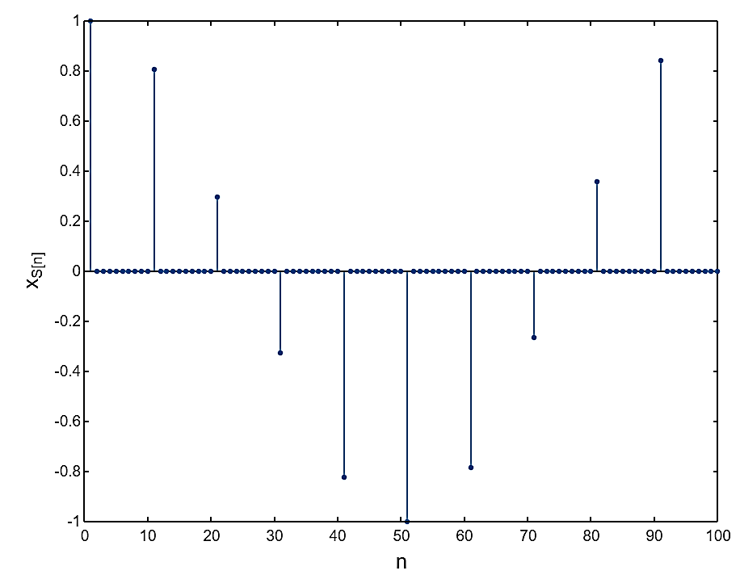

Caption: Plot of sampled signal $x_{S}[n]$.

Task 2

In this task, a reconstruction filter known as Zero-Order Hold (ZOH) filter will be applied to above sampled signal. The ZOH filter impulse response is a square pulse whose duration is one sampling time period, which can consist of M numbers of subsampled ones. The impulse response of ZOH filter is shown below. The figure below is plotted for $M =10$.

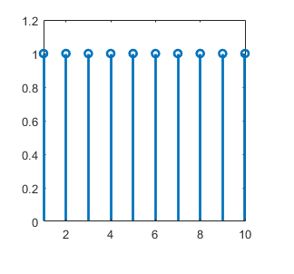

In an additional task you also have to plot the above response of ZOH versus true value of time, keeping in mind the value of sampling time.

The ZOH helps to reconstruct the signal using a staircase approximation.

Now you convolve ZOH impulse response with the sampled signal $X_{S}[n]$ using MATLAB **filter** command to obtain the reconstructed continuous-time signal $X_{ZOH}(t)$. The diagram below illustrates the reconstructed signal obtained by a ZOH filter; only one cycle is illustrated.

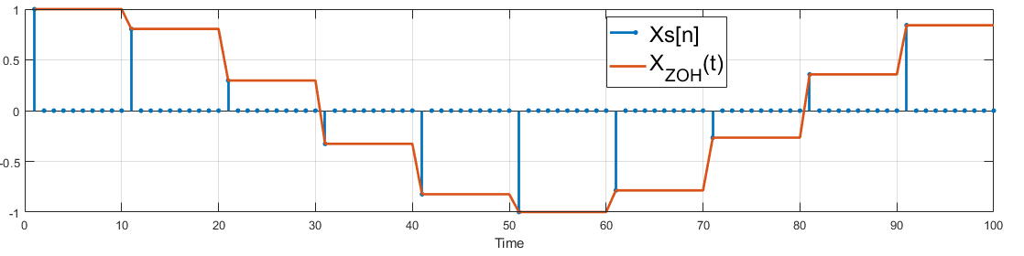

Please note that you are required to show the reconstructed signal up to 3 cycles Show true value of time on x-axis.

Task 2

In this task, a reconstruction filter known as First-Order-Hold (FOH) filter will be applied to the sampled signal. The FOH filter impulse response is a triangular pulse whose duration is from $-T_{S}$ to + $T_{S}$, and consists of $2M$ numbers of elements. The impulse response of FOH filter is shown below.

It must be noted that FOH is an anti-causal filter, since its impulse response starts even before the impulse is applied. Such a filter cannot be implemented in real life scenario. In order to create a causal FOH filter, the impulse response needs to be delayed by one sampling period. A delayed and causal impulse response of FOH filter is shown below (considering $M=10$)

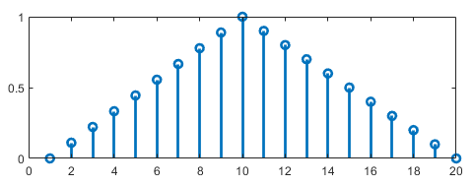

Additionally, you have to plot the above response of FOH versus true value of time, keeping in mind the value of sampling time.

Now you convolve FOH impulse response with the sampled signal $X_{S}[n]$ using MATLAB **filter** command to obtain the reconstructed continuous-time signal $X_{FOH}(t)$. As FOH needs two sample times to process one sample of $X_{S}[n]$, the output obtained is delayed by one sample time. The diagram below illustrates the reconstructed signal obtained by a FOH filter; only one cycle is illustrated.

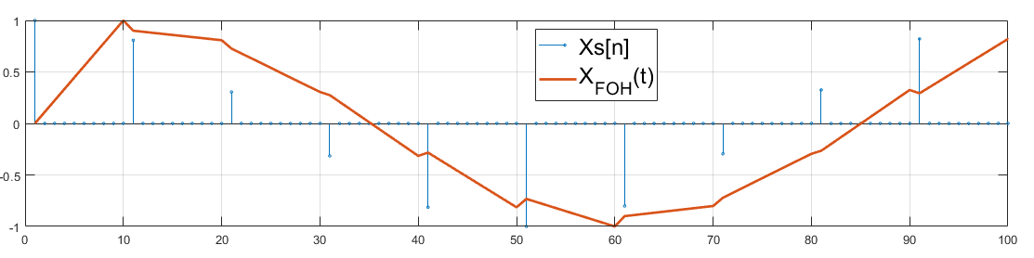

In order to synchronise the both $X_{S}[n]$ and $X_{FOH}(t)$, we can delete first $M-1$ elements of FOH to obtain a plot like below.

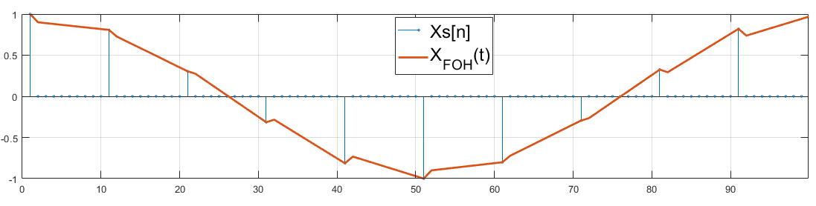

Please note that you are required to show the reconstructed signal up to 3 cycles Show true value of time on x-axis.

Task 3

In this task, a reconstruction filter known as ideal Low-pass Filter (LPF) will be applied to the sampled signal. The $sinc$ function response of an ideal LPF extends infinitely in both positive and negative time domain. In practice, implementing such a filter requires approximations and finite-length representations due to impossibility of infinitely long response. Further, the $sinc$ function-based response is anti-causal in nature. In order to implement a realistic LP filter, its impulse response is truncated and delayed.

In our context, the $sinc$ impulse repose is truncated to six sampling periods ($6T_{S}$). Since, one period contains M elements, the response of LPF contains $6M$ elements. In order to create a causal FOH filter, the impulse response needs to be delayed by three sampling period. The impulse response of LPF is shown below.

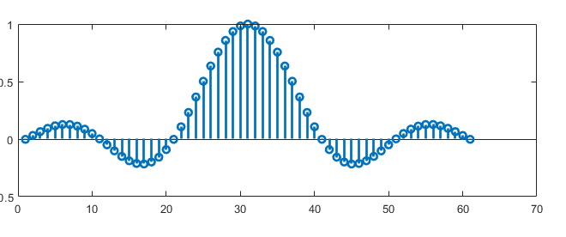

Additionally, you have to plot the above response of LPF versus true value of time, keeping in mind the value of sampling time.

Now you convolve LPF impulse response with the sampled signal $X_{S}[n]$ using MATLAB **filter** command to obtain the reconstructed continuous-time signal $X_{LPF}(t)$. As LPF needs six sample times to process one sample of $X_{S}[n]$, the output obtained is delayed by six sample time. The diagram below illustrates the reconstructed signal obtained by a LPF filter; only one cycle is illustrated.

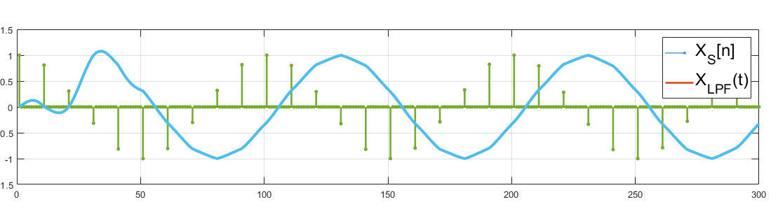

In order to synchronise the both $X_{S}[n]$ and $X_{FOH}(t)$, we can delete first $3M$ elements of FOH to obtain a plot like below.

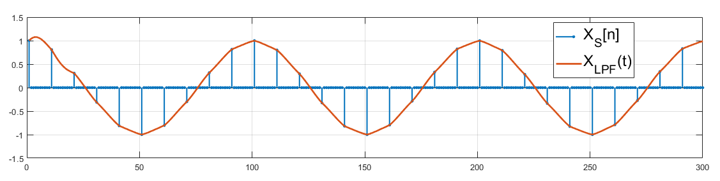

Please note that you are required to show the reconstructed signal up to 3 cycles Show true value of time on x-axis.